
Planner user guide
Designing a FieldKast site: layout, reception, relays, sound and delays
For system designers and anyone planning a FieldKast site with the hosted planner. It covers every tool, overlay and setting, how to read the estimate, and how a plan travels to the installers and the control panel.
Version 1.0, 9 October 2026.

Contents
How the planner works 3
Where it fits in a job 3
Getting started 5
Signing in 5
Your account 5
The screen 5
Working copy, saving and undo 6
Building a plan 7
Find the site 7
Place the stage 7
Place the bridge 8
Draw the audience boundary 8
Draw obstacles 8
Place receivers 9
Reading the results 11
On the map 11
The Estimate for a receiver 11
The Receivers tab 13
Warnings 13
Map overlays 15
Sound level lines and spread lines 16
Auto layout 18
Listen 20
Comparing with a field survey 21
Settings 22
Timing and delays 24
Saving, files and exports 25
Saving to your account 25
Files 25
From plan to site 27
Shortcuts and quick reference 28
Troubleshooting 29
What the estimate does and doesn't include 30

How the planner works
The FieldKast planner is a map tool for designing a site before anything goes out. You place the stage, the bridge and the receivers on a street map or satellite view, draw the audience area and anything in the way, and the planner works out, as you go:
- Reception: how well each receiver will hear the bridge, and what share of the stream it gets.
- Relays: which receivers will relay for others, and for whom, using the same rules as the receivers themselves.
- Timing: each speaker's delay from its distance to the stage, and whether its audio arrives in time.
- Sound: the level across the site, the spill past your boundary, and where the stage and speakers arrive far enough apart to be heard as an echo.
- Airtime: how busy the radio channel will be.
It can also lay the speakers out for you (Auto layout), let you hear a song as it would sound at any spot (Listen), and compare its estimate with a signal survey walked on the real site.
Everything is worked out in your browser as you edit. Plans are saved to your account, so a plan made in the office can be opened by the installers on site.
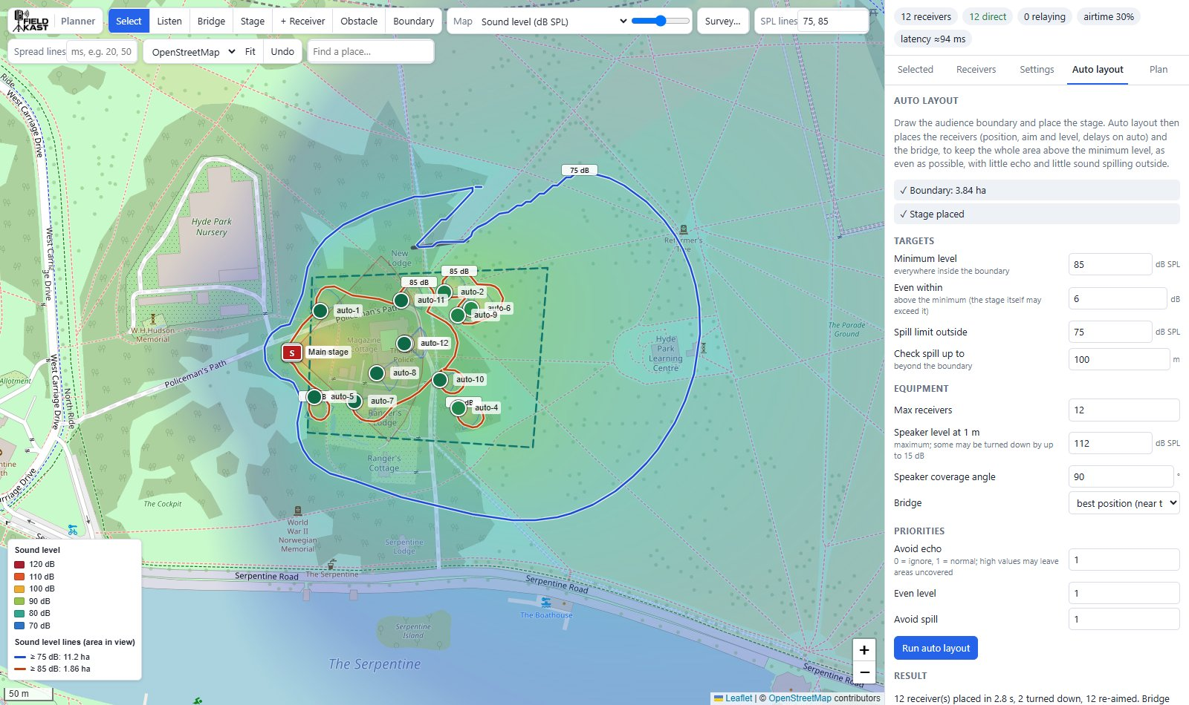
The planner after an auto layout: the map with the sound-level overlay, the stage (S), the receivers, and the side panel.

Where it fits in a job
Stage | What you do with the planner
Site survey | Walk the site with FieldKast Survey and load the result with Survey… to check the radio model against the site
Design | Place the stage, bridge and receivers (or use Auto layout), check reception, timing, coverage, spill and echo; Plan > Save
Installation | The installer app opens the saved plan on each installer's phone and guides them to every position
Bring-up | Open the installed plan the installer app saved; delays are worked out again from where the units really went; Delays for panel for the control panel
After the event | Import levels from the control panel, so next year's plan starts from measured speaker levels

Important: Everything the planner shows is an estimate for planning. The default radio model comes from a line-of-sight walk test over open grass, where receivers held the stream to at least 250 m. Obstacles, crowds and interference on your site cost range: walk-test new sites.

Getting started

Signing in
Open the planner's address in a browser (Chrome, Edge, Safari or Firefox, on a laptop or desktop: the planner needs a mouse and a reasonably large screen). There is no password: the planner emails you a link and a 6-digit code.
- Enter your email address and click Email me a sign-in link.
- Open the email. Click the link on this computer, or type the 6-digit code into the page if you read your email somewhere else (for example on your phone).
- You are signed in for 30 days from your last visit, on this browser.
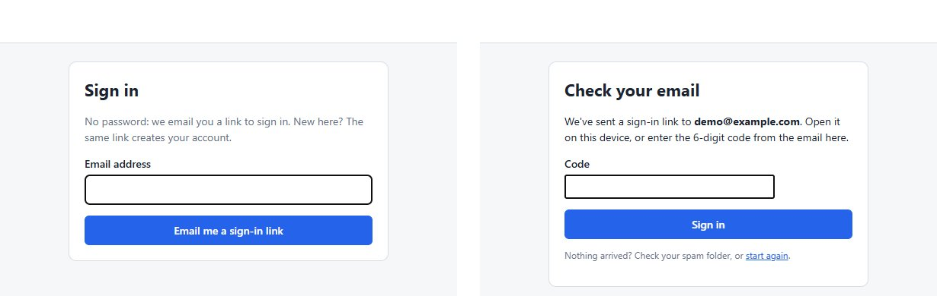
Signing in: your email address, then the code from the email.
The first sign-in with a new address creates your account. Links and codes work once, for 15 minutes. If nothing arrives, check your spam folder or start again.
Tip: The installer app uses the same account. Sign in to it on each installer's phone with the address the plan is saved under, so they can open it.

Your account
Plan > Account opens your account page, where you can:
- change the name shown in the planner;
- see your subscription and, where billing is on, Subscribe or Manage billing;
- see the devices you are signed in on, and Sign out everywhere else;
- delete your account and all its saved plans.
Administrators also see Admin, for managing users. Your saved plans are private to your account.

The screen
The toolbar along the top of the map.
The screen has three parts:
- The toolbar along the top of the map: the tools, the map overlay, survey, level lines, base map, Fit, Undo and place search.
- The map, with a legend bottom left, a scale bar, zoom buttons bottom right, and a readout along the bottom that shows the estimate wherever the pointer is.
- The side panel on the right: the summary chips at the top, then five tabs: Selected, Receivers, Settings, Auto layout and Plan.
The summary chips give the state of the whole plan at a glance:
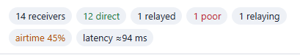
The summary chips.
Chip | Meaning
N receivers | Receivers in the plan
N direct | Receivers that hear the bridge well enough on their own (90% of the stream or more)
N relayed | Receivers that get 90% or more only through another receiver relaying
N poor | Receivers that get under 90% by any route: expect dropouts
N relaying | Receivers that will relay for others
airtime N% | How busy the radio channel is. Amber over 35%, red over 50%
latency ≈N ms | Time from audio in at the transmitter to sound out of a speaker with no delay of its own
N late | Receivers whose audio would arrive too late to play (red)

Working copy, saving and undo
The plan you are working on is kept in your browser automatically, so closing the tab loses nothing. To keep a plan, share it with the installers, or work on it from another computer, save it to your account: Plan > Save (see Saving, files and exports).
Undo (or Ctrl+Z) takes back the last change, up to 80 steps; Ctrl+Y or Ctrl+Shift+Z redoes it.

Building a plan
A plan is built in this order. Each step is described below.
- Find the site.
- Place the stage.
- Place the bridge.
- Draw the audience boundary (needed for Auto layout).
- Draw obstacles.
- Place the receivers, by hand or with Auto layout.
- Check the results, then save.

Find the site
Type a place name, postcode or address into Find a place… and press Enter. Pan by dragging the map and zoom with the mouse wheel or the + and − buttons. OpenStreetMap / Satellite switches the base map: satellite imagery shows tents, tree lines and hard standing that a street map doesn't.
Fit zooms to everything in the plan.

Place the stage
Choose Stage and click the map at the main PA's acoustic centre. Delays are measured from here, so place it carefully. Then, in the Selected tab, set:
Field | Default | Notes
Name | stage | Shown on the map
Level at 1 m | 128 dB SPL | The main PA, continuous, on axis
Coverage angle | 90° | 360 for an omnidirectional source
Aim | towards the receivers (or audience area) | Or manual bearing, clockwise from north
Main PA latency | 0 ms | Audio in to stage sound. 0 if the PA is fed directly from the desk; about the FieldKast latency if the main PA is fed through FieldKast too

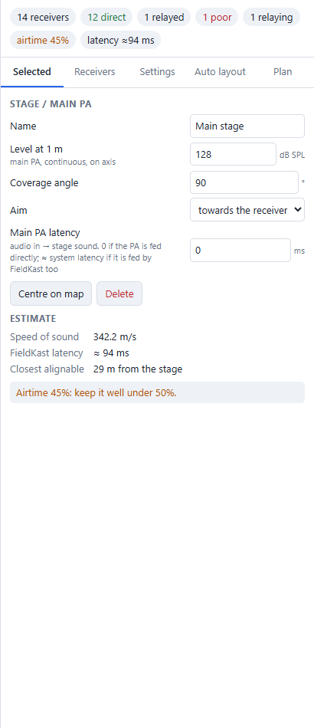
The stage's settings and estimate.
The Estimate under it shows the speed of sound at the set air temperature, the FieldKast latency, and the Closest alignable distance: speakers nearer the stage than this can't be delayed enough to line up with it.

Place the bridge
Choose Bridge and click where the bridge antenna will go, usually on a mast near the front-of-house position. Set its Antenna height (default 4 m; mount it high) and Antenna gain (default 2 dBi). Reception is worked out from here, so until the bridge is placed the receivers show grey.
The bridge's Estimate shows how many receivers hear it directly, its EIRP (transmit power plus antenna gain, which must not exceed 20 dBm in the UK and EU), the size and airtime of each packet, and the airtime used by the bridge and by relays.

Draw the audience boundary
Choose Boundary and click around the audience area, one point per corner. Double-click, or press Enter, to finish; Esc cancels. The boundary is a dashed green outline. A plan has one boundary; drawing another replaces it.
The boundary is what Auto layout fills with sound, and what it keeps spill outside of. Select it to see its area and perimeter.

Draw obstacles
Choose Obstacle and click along anything that blocks radio or sound: a marquee wall, a building, a tree line, a parked lorry. Double-click or Enter to finish, Esc to cancel. Then set its losses in the Selected tab:
Field | Default | Typical values
Radio loss | 10 dB | Tent 3–6, tree line 6–12, wall or vehicle 10–20, building 20 or more
Sound loss | 10 dB | Per crossing

Every radio link and sound path that crosses the line loses that much. An obstacle is a line, not an area: draw the side that faces the bridge or stage.
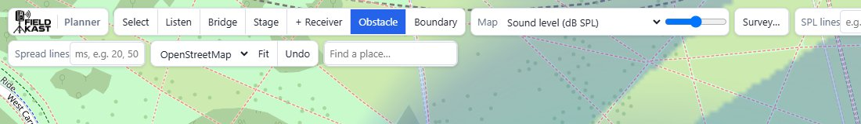
The hint shown while drawing an obstacle.

Place receivers
Choose + Receiver and click the map once for each receiver. Each one is named rx-1, rx-2 and so on, with the defaults from Settings > New receivers. Press Esc when done.
- Move a receiver, the stage or the bridge by dragging it.
- Select it by clicking it (with the Select tool), or its row in the Receivers tab.
- Delete the selected item with the Delete key, or Delete in the Selected tab.
- Turn a speaker by dragging its coverage cone: the aim follows the pointer and becomes a manual bearing.
Each receiver has these settings in the Selected tab:
Field | Default | Notes
Name | rx-N | Up to 16 characters on the receivers; the control panel shows it
MAC | blank | Filled in on site by the installer app when the unit is scanned. Needed to send the receiver its delay
Relay mode | auto (relay when asked) | on always relays; off never relays (it can still be relayed to)
Antenna height | 2.5 m | Above head height: a crowd absorbs 2.4 GHz
Antenna gain | 2 dBi
Level at 1 m | 112 dB SPL | Continuous, on axis. Replaced by the measured level once the speaker has been measured
Coverage angle | 90° | 360 for omnidirectional
Aim | away from the stage | Or manual bearing, clockwise from north
Delay | auto (from stage distance) | Or manual, in ms
Trim | 0 ms | Added to the delay, auto or manual

Centre on map pans to the item.

Measured speaker levels
Once a speaker has been measured (with the installer app on site, or the control panel's Calibrate, brought in with Import levels), its Speaker section shows Measured level (dB(A) at 1 m, with the test noise at full volume) and Volume (as set on the receiver) instead of Level at 1 m. The level used in the sound model is the measured level, plus the volume, plus Settings > Programme vs test noise. Forget measurement goes back to a typed level.

Installed positions
A plan saved by the installer app has each unit where it was really put. Its Selected tab says when it was installed, how far from its planned position, and how accurate the GPS was; if the speaker was aimed on site, its recorded bearing. Back to planned position puts it back where the plan had it.

Reading the results

On the map
What you see | Meaning
Red square S | The stage
Dark square B | The bridge
Round marker | A receiver. Its colour is its total reception, on the same scale as the Reception overlay: dark green 99.9%, green 99%, yellow-green 97%, yellow 90%, orange 80%, red 50% and below. Grey until the bridge is placed
Number in a marker | Its hop level: 1 = fed through one relay, 2 through two. Blank = direct. × = no usable signal
Ring around a marker | This receiver relays for others
Blue outline round a marker | The selected item
Thick line with an arrow | A relay link, from the relaying receiver to the one it feeds, coloured by the link's quality. Point at it for the share of the stream and the signal
Thin dashed lines from the bridge | Direct bridge links (only with Settings > Show bridge links)
Pale wedge from a speaker | Its coverage angle, drawn out to where it falls to the Target level (blue for speakers, red for the stage)
Dashed green outline | The audience boundary
Thick grey line | An obstacle

The readout along the bottom of the map shows the estimate at the pointer: the bridge signal and distance, the reception a receiver would get there (and through which relay), the sound level and arrival spread, and the distance to the stage. With a survey loaded it also shows the measured signal nearby.

The Estimate for a receiver
Select a receiver to see its estimate under its settings:
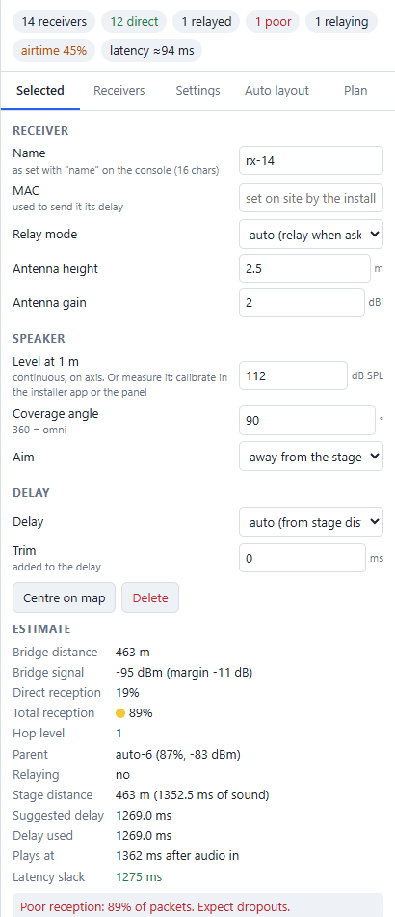
A receiver out past the bar tent, fed through a relay, with a reception warning.
Line | Meaning
Bridge distance | Straight-line distance to the bridge
Bridge signal | The signal from the bridge, and its margin above what the receiver needs
Direct reception | Share of the stream it hears straight from the bridge
Total reception | Share it gets by any route, direct or relayed. 97% or more is good; under 90% means dropouts
Hop level | Direct, or how many relays the stream passes through
Parent | The receiver relaying for it, with that link's share and signal
Relaying | Whether it relays, and for whom
Stage distance | Distance to the stage, and how long sound takes to travel it
Suggested delay | The delay that lines it up with the stage (see Timing and delays)
Delay used | Auto or manual, plus trim
Plays at | When its sound leaves the speaker, after audio enters the transmitter
Latency slack | How early its audio arrives before it would count as late. Green 10 ms or more, amber under 10 ms, red below 0

Any warnings for it follow (see Warnings).

The Receivers tab
A table of every receiver: its reception colour and name (R if it relays, a green tick if it has a MAC), hop level, total reception (Rx), parent, delay and slack, with a red or amber dot if it has a warning. Click a row to select the receiver and centre the map on it.
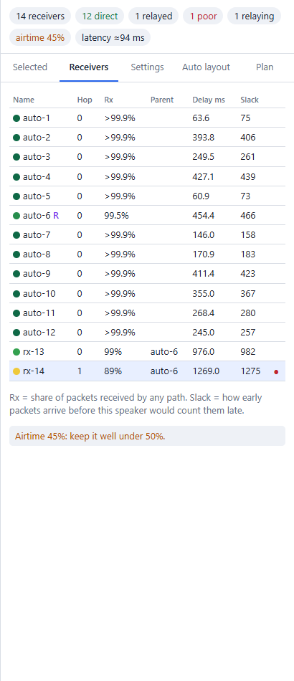
The Receivers tab.

Warnings
Warnings appear in red (a problem) or amber (worth checking) under the selected item's estimate, and the plan-wide ones also under the Receivers table and the bridge and stage estimates.
Warning | What to do
No usable signal (N%) | Move the receiver closer, raise its antenna, or add a receiver in between to relay
Poor reception: N% of packets. Expect dropouts. | As above. Under 90% the receiver will ask for a relay; check it has a good one
Marginal reception: N% of packets | Some lost audio is likely (concealed, so usually inaudible). Raise the antenna or move it a little
Wants a relay but no neighbour is good enough to be its parent | No receiver nearby hears well enough to relay to it. Add one in between, or move it
Packets arrive N ms late | Its audio arrives after it should play. Raise the stream delay (Settings > Delay), give this receiver more delay, or give it a shorter relay route
Only N ms of latency slack | It works on paper, with little to spare for a busy radio channel
Delay N ms exceeds the 2.56 s jitter buffer | The receiver can't hold audio that long: a speaker this far out needs a special build of the receivers
Too close to the stage to align | FieldKast arrives this much after the stage sound here, whatever the delay. Move it further out, or feed the main PA through FieldKast too
Parent of N units | One receiver relays for more than the 8 it can track. Spread the relaying, or move receivers
Name longer than 16 characters | The receivers keep 16 characters: shorten it
Place the bridge / Place the stage | Needed for reception and for delays
Airtime N%: over 50% | The channel is too busy. Use a higher air rate, a lower bitrate, or fewer relays
Airtime N%: keep it well under 50% | Over 35%: check it is acceptable
EIRP up to N dBm | Over the UK/EU limit of 20 dBm. Lower the TX power to 20 minus the antenna gain
Relay selection did not settle | Receivers here might switch back and forth between relays. Move one so the choice is clearer
N receiver(s) would get late packets | See "Packets arrive N ms late"

Map overlays
The Map list colours the whole view with one estimate; the slider beside it sets how strong the colours are. The legend bottom left explains the colours. Overlays are worked out for the part of the map in view, so zoom in for detail.
Overlay | Shows | Use it to
No overlay | Just the plan
Reception (new receiver here) | The share of the stream a new receiver would get at each spot, direct or through the existing relays: dark green 99.9%, green 99%, yellow-green 97%, yellow 90%, orange 80%, red 50% and below | Find good receiver positions
Relay hops (new receiver here) | How many relays a new receiver at each spot would go through: green direct, blue 1 hop, purple 2, pink 3, red 4. Faded where reception would be under 90% | See how far the relay tree reaches
Bridge signal (dBm) | The signal from the bridge alone, from blue (strong, −45 dBm) to red (−100 dBm) | Compare with a survey; choose the bridge position
Sound level (dB SPL) | The level from the stage and every speaker together, from blue (70 dB) through green (85), yellow (95) and orange (105) to red (115 and over) | Check coverage and spill
Arrival spread / echo (ms) | The time between the earliest and latest arrivals of the loud sources at each spot: green under 10 ms (fused), yellow 20–30 ms, orange 30–50 ms (echo risk), red over 50 ms (heard as an echo). Places more than 20 dB below the target level are left clear | Find echo problems

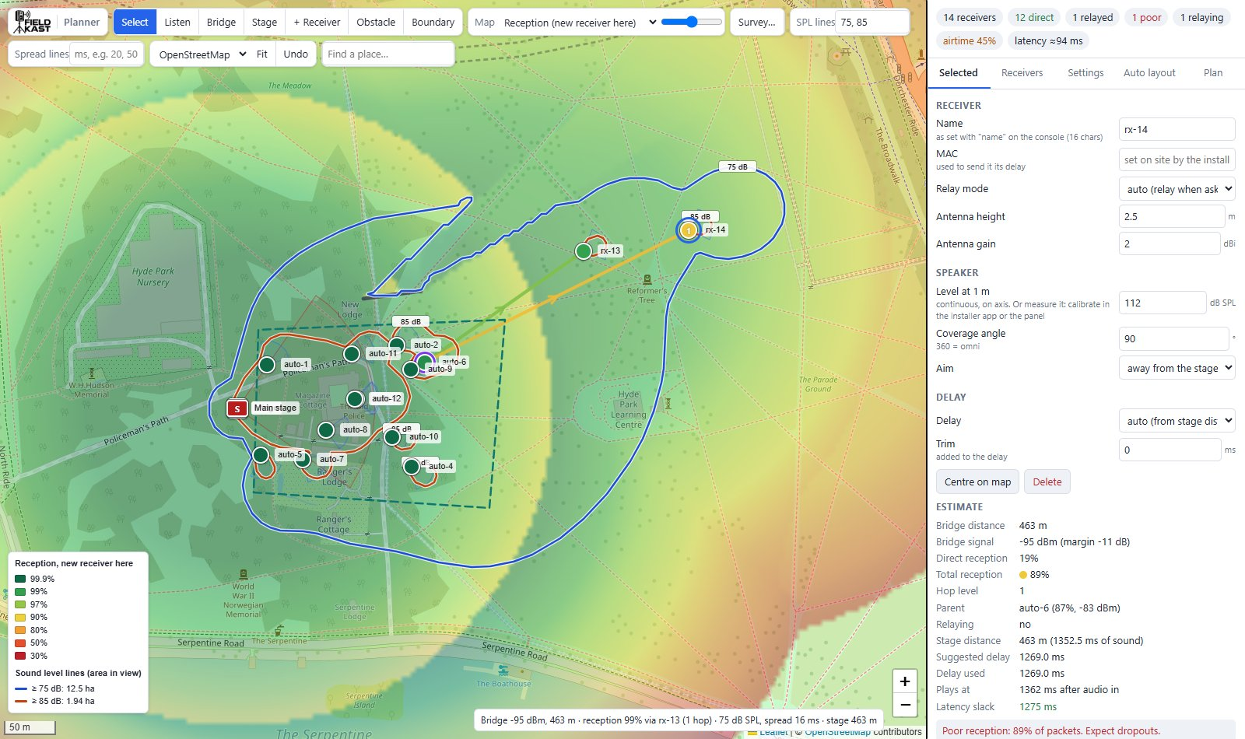
Reception (new receiver here).
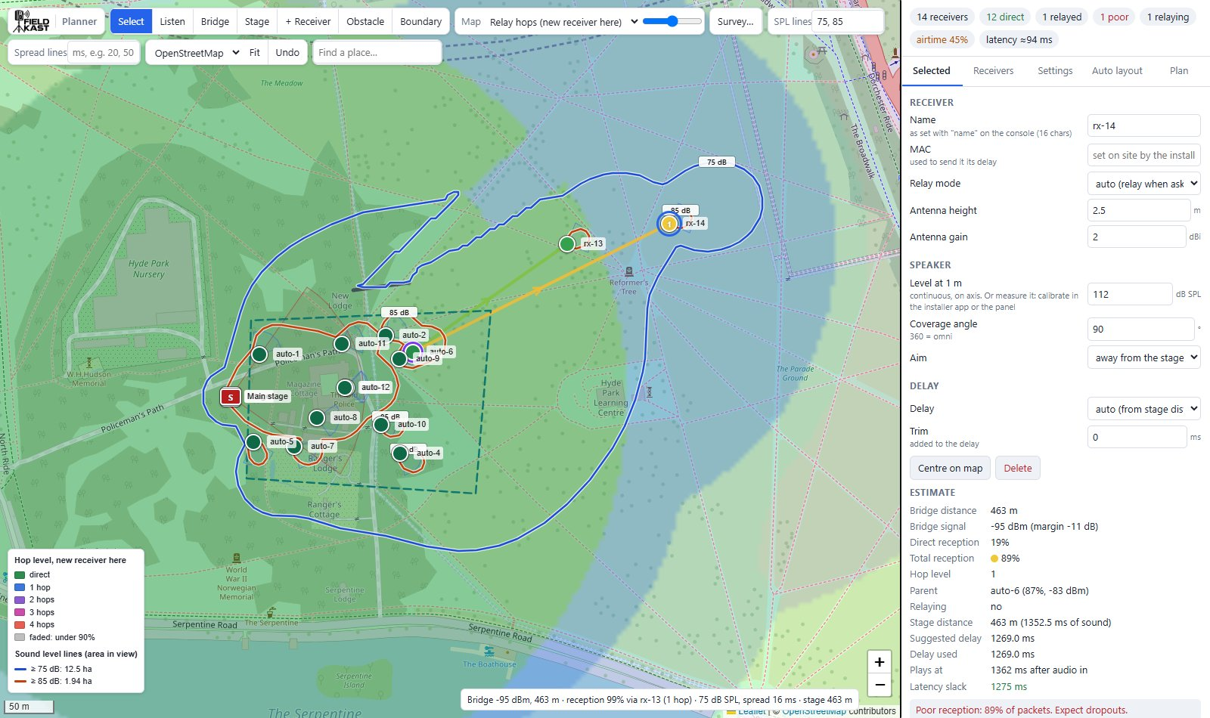
Relay hops: the far receiver is fed through one relay.
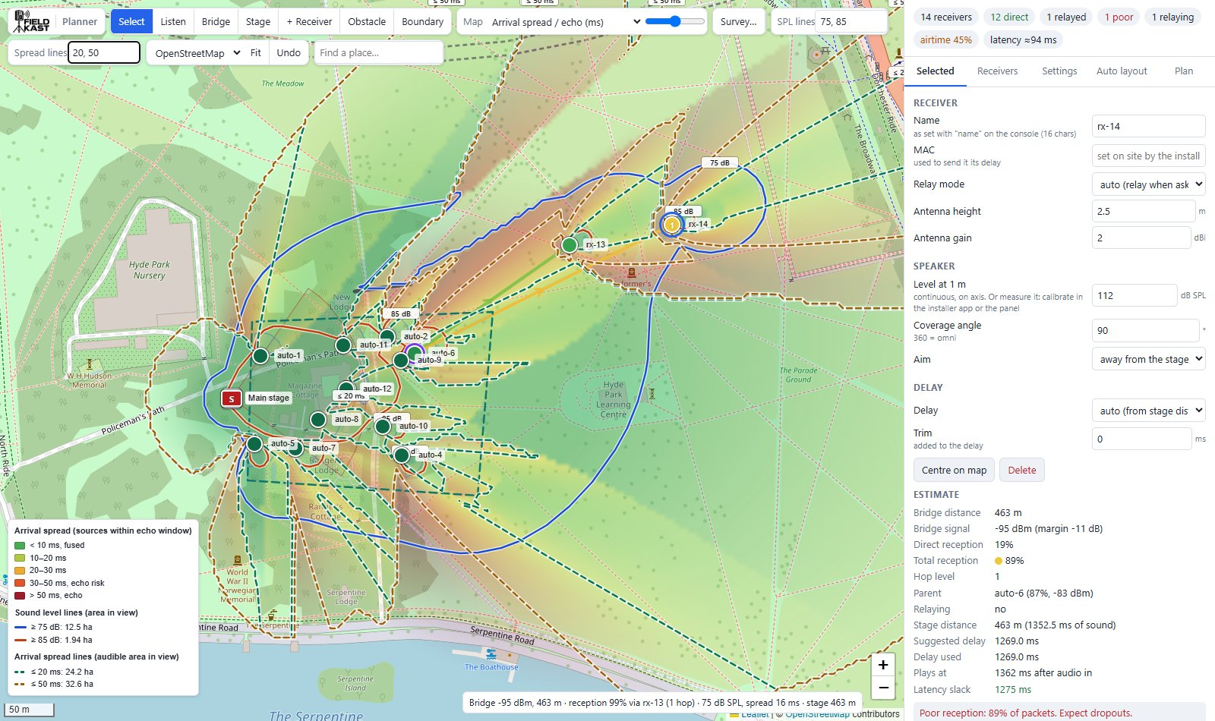
Arrival spread, with spread lines at 20 and 50 ms.

Sound level lines and spread lines
Type levels into SPL lines, separated by commas (for example 85, 100), to draw a line round every area at or above each level, up to six levels. The legend gives the area inside each line, within the view.
Spread lines do the same for arrival spread, in ms (for example 20, 50): the dashed line surrounds the areas where the stage and speakers arrive within that time of each other.
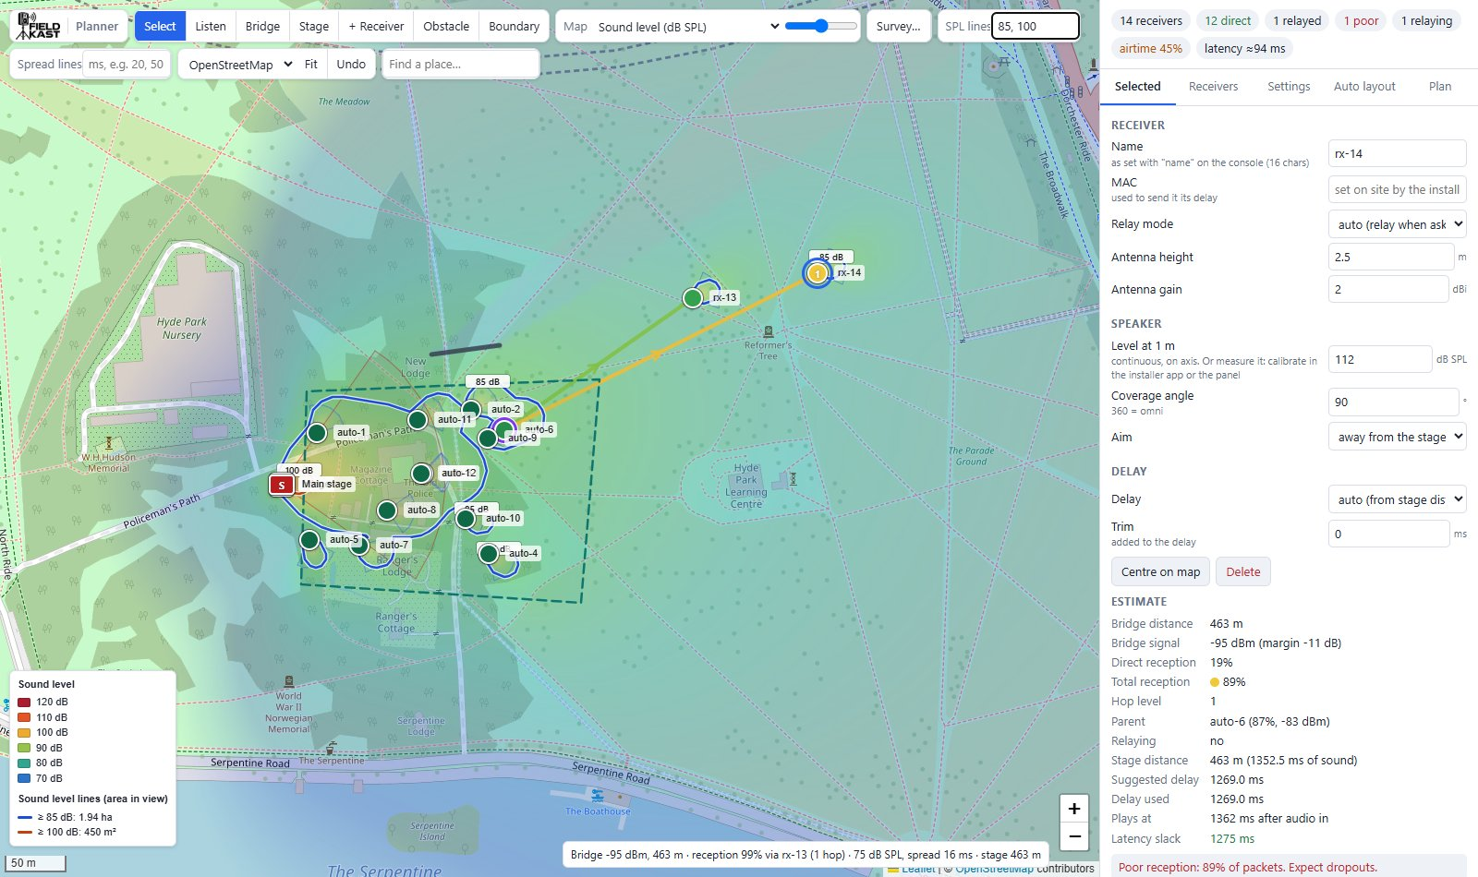
Sound level with lines at 85 and 100 dB.
Tip: A line at your licence's boundary limit shows at a glance where the spill is. Auto layout draws lines at the minimum level and the spill limit for you.

Auto layout
Auto layout places the receivers for you: their positions, aims and levels (with delays on auto), and the bridge. It aims to keep the whole audience area above a minimum level, as even as possible, with little echo and little sound spilling outside.
- Draw the audience boundary and place the stage. The Auto layout tab shows a tick against each.
- Set the targets, the equipment and the priorities (below).
- Click Run auto layout. It takes from a few seconds to a minute; the status line shows its progress, and Cancel stops it with nothing changed. If the plan already has receivers it asks first, as they are replaced.
- Read the result, check the Arrival spread overlay for echo, and fine-tune by dragging receivers. Undo brings the previous layout back.
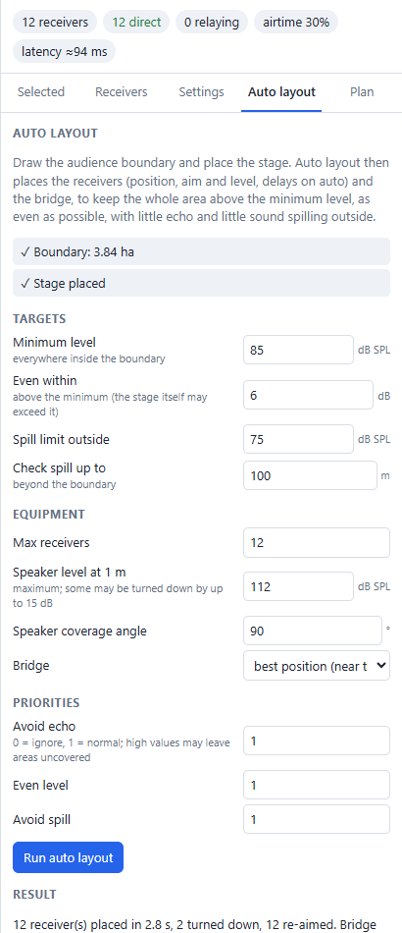
Auto layout settings and its result.
Setting | Default | Meaning
Minimum level | 85 dB SPL | Wanted everywhere inside the boundary
Even within | 6 dB | How far above the minimum it should stay (the stage itself may exceed it)
Spill limit outside | 75 dB SPL | The most wanted outside the boundary
Check spill up to | 100 m | How far beyond the boundary spill is checked
Max receivers | 20 | The most it may place
Speaker level at 1 m | 112 dB SPL | The speakers' maximum; some may be turned down by up to 15 dB
Speaker coverage angle | 90° | Narrower angles usually give less echo
Bridge | best position | Best position (near the stage preferred), at the stage, or keep where it is
Avoid echo | 1 | Priority weights: 0 ignores it, 1 is normal. High values may leave areas uncovered
Even level | 1
Avoid spill | 1

The Result compares the stage alone with the layout: the share of the area at the minimum level, the level range (10th to 90th percentile), the share with echo risk (arrivals over 30 ms apart), the share outside over the spill limit, and the loudest level outside. Warnings follow if coverage is under 95%, echo over 5%, spill over 20%, any receiver has poor reception, or airtime is over 50%.
When it finishes, the map shows the Sound level overlay with lines at the minimum and the spill limit.
Tip: Auto layout works best with a realistic speaker level. If the speakers have been measured before, use that level.

Listen
Listen plays a song as it would sound at a spot on the map: the stage and every speaker with a usable signal, each at its modelled level and arrival time, duller with distance, and panned left or right by direction as if you were facing the stage.
- Choose Listen and click the map. The first time, it asks for a song: any audio file the browser can play (MP3, WAV and so on).
- A headphones marker shows where you are listening. Drag it, or click elsewhere, to move; the sound follows as it plays.
- The player lists what you hear: each source's distance, how much later it arrives than the first, and its level. Arrivals in red are echoes (over 50 ms late and loud); amber over 20 ms.
- Play/Stop starts and stops it, Vol sets the volume, ✕ closes it.
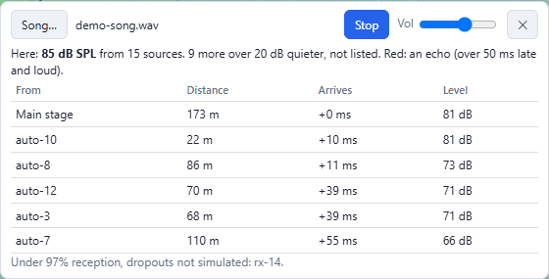
The Listen player.
100 dB SPL plays at full scale, so set the volume once and quiet spots then sound quiet. Moving or turning speakers while it plays updates it. Reception dropouts and reflections are not simulated.

Comparing with a field survey
FieldKast Survey is a phone app for walk tests: at each spot you record the signal strength and reception shown on a receiver, with the GPS position. Export the survey from the app as a GeoJSON file, then click Survey… in the planner and choose the file.
- Every recorded point is marked, with its readings when you point at it.
- Points recorded at 100% reception are blended into a heat map of measured signal, on the same colours as the Bridge signal overlay, up to 25 m from each point. Points below 100% are hollow and left out of the heat map.
- The readout shows the measured signal near the pointer.
Compare it with the Bridge signal overlay: if the site measures worse than the model, add Extra fade margin or crowd loss in Settings. The survey is kept in the plan; ✕ beside the Survey button removes it.

Settings
The Settings tab holds the settings for the whole plan. Most can be left at their defaults; the ones that matter most are the air rate, the stream settings, the air temperature and the crowd loss. Reset settings to defaults puts them all back (keeping the overlay, base map and level lines).

Radio
Setting | Default | Notes
Air rate | 802.11b 1 Mb/s | As the system will run. The control panel can switch between 1, 2 and 5.5 Mb/s; other rates are fixed when the units are built
TX power | 18 dBm | Transmit power. 20 minus the antenna gain at most
RX sensitivity | blank | The weakest signal a receiver can use. Blank uses the floor measured on the field survey (or the rate's own figure if worse)
Bridge copies | 2 | Each packet is sent this many times
Relay copies | 1 | Copies each relay sends
Max hops | 4 | How many relays deep the stream can go
Forward-first relays | on | Relays pass audio on before checking it, so each hop adds only a few ms

Propagation
Setting | Default | Notes
Model | Measured (field survey) | Fitted to a real walk test on open grass (antenna heights ignored). Open field (two-ray) uses antenna heights; Log-distance has a path-loss exponent (2 open, 2.7–3.5 crowded); Free space is the best case
Crowd / clutter loss | 2 dB/100 m | 2 matches the empty field surveyed; 2–4 a light crowd, 8–15 a dense crowd at head height
Fading spread σ | 4 dB | The uncertainty around the average signal
Extra fade margin | 0 dB | Make the estimate more pessimistic

New receivers
The defaults for receivers you add: Antenna height 2.5 m (also used by the reception overlays), Antenna gain 2 dBi, Speaker level at 1 m 112 dB and Coverage angle 90°. Apply radio defaults to all receivers sets every receiver's antenna height and gain to these.

Stream and timing
These must match how the transmitter is set up; the defaults are those of a new FieldKast transmitter.
Setting | Default | Notes
Opus bitrate | 80 kb/s | Audio bitrate
Channels | mono | Or stereo
Frames per packet | 1 (20 ms)
Delay | 60 ms | The stream delay, as set in the control panel
Signature check | 27 ms | Used only without fast authentication
Fast authentication | on | The low-latency mode new transmitters use
Per hop (forward-first) | 6 ms | Extra time per relay

Acoustics
Setting | Default | Notes
Air temperature | 18 °C | Sets the speed of sound, and so the delays. Use the forecast for show time
Programme vs test noise | 0 dB | How much louder the show is than the calibration noise; 0 for typical mastered music. Applies to measured speakers
Precedence offset | 10 ms | Delay speakers this much past the stage sound, so the sound still seems to come from the stage
Air absorption | 5 dB/km | About 5 at 1 kHz, 20 at 4 kHz
Echo window | 10 dB | Sources within this of the loudest count towards arrival spread
Target level | 85 dB SPL | The coverage cones show the throw to this level

Display
Overlay cell size (6 px; smaller is finer and slower), Show bridge links, Show names and Show speaker coverage.

Timing and delays
Each speaker must play a little after the stage sound reaches it, so the audience hears one source, from the stage. With delay on auto the planner works it out:
- Suggested delay = stage distance ÷ speed of sound + precedence offset − (FieldKast latency − main PA latency).
- FieldKast latency is about 34 ms plus the stream delay: about 94 ms with the default 60 ms.
- Closest alignable (stage estimate) is where the suggested delay reaches zero. Nearer than that, FieldKast arrives after the stage sound whatever the delay.
The speed of sound depends on the air temperature: about 6 ms per 100 m between a cool morning and a hot afternoon. If the temperature on the day differs from the plan by more than about 10 °C, change it and apply the delays again.
Latency slack is how early each speaker's audio arrives before it must play. Relays add a few ms each, but speakers far out also have long delays, so deep relaying is fine far from the stage. A receiver several relays deep but close to the stage is the one to watch.

Saving, files and exports
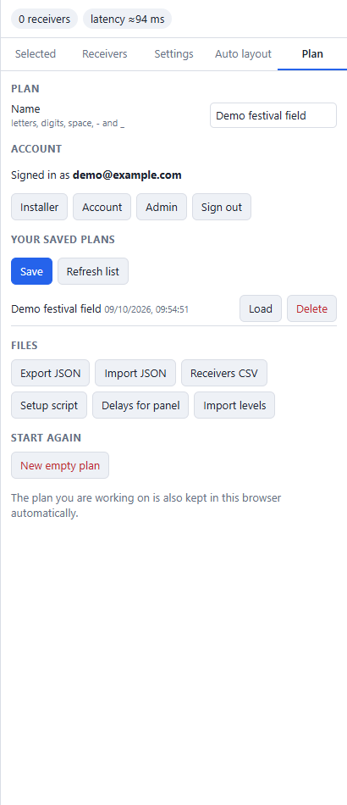
The Plan tab.

Saving to your account
- In Plan, give the plan a Name (letters, digits, spaces, - and _; up to 64 characters). Use the job number.
- Click Save. Saving under an existing name replaces that plan.
Your saved plans lists them, newest first, with Load and Delete. Refresh list fetches the list again (for example after the installer app has saved). An account holds up to 500 plans.
After saving or loading, the browser's address ends ?plan=<name>: bookmark it to open that plan directly.
New empty plan clears the stage, bridge, receivers and obstacles but keeps the settings (Undo brings them back).

Files
Button | What it does
Export JSON | Downloads the whole plan as a file (<name>.fieldcast-plan.json), for backup or to send to someone with another account
Import JSON | Opens a plan file. It replaces the working plan (Undo brings the old one back)
Receivers CSV | A spreadsheet of the receivers: name, MAC, position, relay mode, estimated reception, hop level, parent, relaying, stage distance, delay, slack and warnings
Setup script | A script for engineers that sets each receiver's delay from the transmitter's command line. The control panel's Apply delays does the same job and is the usual way
Delays for panel | The file the control panel's Apply delays… takes: each receiver's delay and name, and its measured level if it has one, keyed by MAC
Import levels | Takes the control panel's Levels for planner file and sets each receiver's measured level and volume, matched by MAC

Important: Delays for panel only includes receivers with a MAC, which the installer app records on site. Receivers without one are listed and left out; type a MAC into the receiver's Selected tab if needed. Delays over 2000 ms (the receivers' limit) are capped. With no stage placed every delay is 0, and it asks before exporting.

From plan to site
- Design the plan and Save it.
- On site, installers open it in the installer app (Menu > Open saved plan), walk to each position, scan each unit's QR code, aim it and measure its level. Menu > Save to planner saves the installation to your account as a new plan, "<plan> installed".
- In the planner, Refresh list and Load the installed plan. Each unit is where it was really installed, with its MAC, aim and measured level, and the delays are worked out again from the real distances. Check the air temperature for show time.
- Plan > Delays for panel.
- In the control panel, Apply delays… with that file, ticking Also set names from the plan and Also store measured levels.
After the event, the control panel's Levels for planner and the planner's Import levels bring any levels measured later back into the plan, ready for next time.

Shortcuts and quick reference
Key or action | Does
Esc | Back to Select; cancels a line being drawn
Enter or double-click | Finishes an obstacle or boundary
Delete or Backspace | Deletes the selected item
Ctrl+Z | Undo
Ctrl+Y or Ctrl+Shift+Z | Redo
Drag an item | Moves it
Drag a coverage cone | Turns the speaker (sets a manual bearing)
Click a row in Receivers | Selects that receiver and centres the map on it

Troubleshooting
Problem | Likely cause | What to do
Receivers are grey | No bridge placed | Place the bridge
Every delay is 0 | No stage placed | Place the stage
No overlay shows | No bridge (for the radio overlays) or no stage or speakers (for the sound overlays) | Place them, or choose another overlay
Run auto layout is greyed out | No boundary or no stage | Draw the boundary and place the stage
"The boundary is too small or not closed" | Too few points inside it | Draw a larger boundary, with at least three corners
Saved plans unavailable | Signed out, or no connection | Reload the page and sign in again; meanwhile use Export JSON
"Expired page: reload it" | The page was open a long time | Reload; the working copy is kept
A subscription is needed | Billing is on for this planner | See Plan > Account
Delays for panel leaves receivers out | They have no MAC | Load the installed plan from the installer app, or type the MACs in
Import levels says "Not in this plan" | The levels file has receivers whose MAC isn't in the plan | Use the installed plan, which has the MACs
Overlay looks blocky or is slow | Overlay cell size | Smaller cells are finer but slower; zoom in for detail

What the estimate does and doesn't include
- Radio: received signal = transmit power + both antenna gains − path loss − crowd loss − obstacles. Each packet copy is another try, and fading is averaged in. The measured model is from one walk test on one site, in line of sight of the bridge.
- Relays: the receivers' own rules, run to a steady state: a receiver hearing under 90% direct picks the neighbour that delivers most (allowing for hops), among neighbours with at least 80% reception. No timing or collisions.
- Airtime: as if every unit hears every other, which is the worst case.
- Sound: inverse square law plus air absorption, −6 dB at the edge of the coverage angle, energy sum of all sources. No reflections, wind, ground effects or crowd absorption of sound.
- Not included: interference from other 2.4 GHz equipment, the crowd's movement, and anything you haven't drawn.
Walk-test new sites with FieldKast Survey, measure speaker levels on site, and check boundary levels with a meter on the day.

